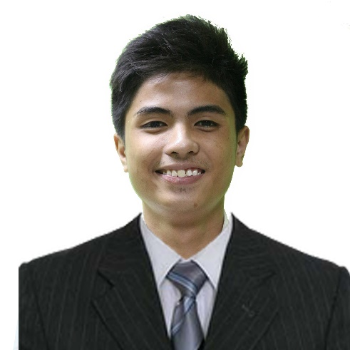

**SERGE ANGELO ISANAN MAJILLO**

home2-512 33 Marulas, Kawit, Cavite

phone-symbol-2 438-6087

27630 sergeangelomajillo@gmail.com

**QUALIFICATIONS**

* Responsible, resourceful, honest, dedicated, and hardworking
* Knowledgeable in Programming and Database Languages (C++, Visual Basic, Python, MySQL, Oracle)
* Knowledgeable in Web Development Tools (HTML, CSS, PHP, Flask)
* Knowledgeable in Mobile Development Languages (Ionic Cordova, ReactJS)
* Knowledgeable in Artificial Intelligence Languages (OpenCV, TensorFlow, PubNub)
* Knowledgeable in Graphic Designing Applications (Adobe Photoshop)
* Willing to learn and expand skills and understanding
* Quickly adapts to project deadlines and changes
* Proficient in English Language (Both oral and written)

**EDUCATIONAL BACKGROUND**

**Tertiary Education**

San Sebastian College-Recoletos de Cavite

November 2014 – March 2019

**Secondary Education**

Emiliano Tria Tirona Memorial National High School

June 2010 – March 2014

**WORK EXPERIENCE**

**READS (Recoletos Educational Assistance for Deserving Students) Grantee**

San Sebastian College-Recoletos de Cavite

November 2014 – October 2017

**On-The-Job Trainee**

AdaptDev Web Solutions, Incorporated

April 2018 – September 2018

**Deliveroo Rider Support Representative**

TaskUs Lizzy’s Nook

December 2017 – Present

**OBJECTIVE**

To be hired in a position where I can share my knowledge, interests and experiences in the field of Information Communication Technology, specifically in website and software development.

**SEMINARS AND TRAININGS**

**TechTutor 8**

SM Megatrade Hall 1 & 2

September 28, 2016

**Cavite Youth IT Convention**

SM City Bacoor

September 8, 2017

**TechTutor 9**

SM Megatrade Hall 1 & 2

September 27, 2017

**CHARACTER REFERENCES**

**Mrs. Agnes V. Bernal**

Faculty, Computer Studies Department

San Sebastian College – Recoletos de Cavite

09154892173

**Mr. Antonio C. Co, MBA**

Head, Computer Studies Department

San Sebastian College – Recoletos de Cavite

(046) 431-0861 loc. 745

**Ms. Jedilyn Volante**

Computer Laboratory Custodian

San Sebastian College – Recoletos de Cavite

(046) 431-0861 loc. 743

**PERSONAL INFORMATION**

**Age:** 20

**Birth Date:** January 21, 1998

**Birth Place:** Binakayan, Kawit, Cavite

**Citizenship:** Filipino

**Civil Status:** Single

**AFFILIATIONS**

**READS (Recoletos Educational Assistance for Deserving Students)**

San Sebastian College-Recoletos de Cavite

November 2014 – October 2017

**Junior Philippine Computer Society (JPCS)**

San Sebastian College-Recoletos de Cavite

November 2014 – Present